Multifreq AFMSuite Guide

Massimiliano Galluzzi1, Michele Lancia2,3, Chunmiao Zheng2,3, Viviana Re4, Xue-Feng Yu1, Stefano Viaroli5

1 Materials and Interfaces Center, Shenzhen Institute of Advanced Technology, Chinese Academy of Science, Shenzhen, China.

2 Guangdong Provincial Key Laboratory of Soil and Groundwater Pollution Control, School of Environmental Science and Engineering, Southern University of Science and Technology, Shenzhen, China

3 State Environmental Protection Key Laboratory of Integrated Surface Water-Groundwater Pollution Control, School of Environmental Science and Engineering, Southern University of Science and Technology, Shenzhen, China

4 Department of Earth Sciences, University of Pisa, Pisa, Italy

5 Sciences Department, Roma Tre University, Rome, Italy

Massimiliano Galluzzi and Michele Lancia equally contributed

Correspondence: Massimiliano Galluzzi, [galluzzi@siat.ac.cn](mailto:galluzzi@siat.ac.cn); Chunmiao Zheng, [zhengcm@sustech.edu.cn](mailto:zhengcm@sustech.edu.cn)

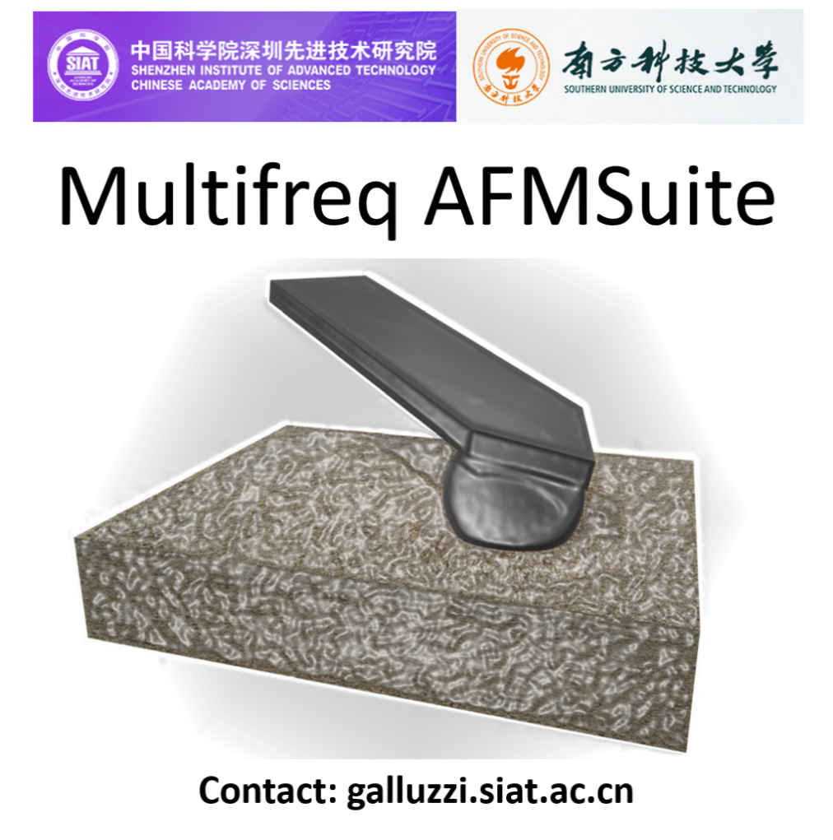

# Introduction

For a complete and advanced data analysis of multifrequency mechanical imaging we developed Multifreq AFMSuite, which is a software similar to general mechanics software AFMech Suite1, but focused on multifrequency mapping. This suite is written in Matlab language using event/object programming to provide an alternative tool for basic or advanced analysis of AFM nanomechanical maps. The analysis is real-time allowing the user to controleach step of analysis.

Multifreq AFMSuite is dedicated to AFM beginner level to expert level with nanomechanics experience. The graphical user interface does not require knowledge of Matlab language. After the analysis, the user can export all graphical results using several formats. Moreover, the software can create custom metadata to save time and quickly reload previous analysis.

The purpose of this manual is to help the unfamiliar users to perform the analysis using all the software functions, and mainly to explain/justify the features operations. References to recent literature will help the interested users to find additional material and explanation about nanomechanics by AFM. During the analysis, hints and warnings will support the users.

If problems or bugs regarding the software is experienced, please contact the authors in order to solve it and improve Multifreq AFMSuite. Software will be freely available on e-mail request to the authors.

List of commonly used abbreviations:

* AFM --- Atomic Force Microscopy
* E --- Young’s Modulus
*  --- Poisson`s ratio
* **[button]** --- Buttons name on interface, between square brackets
* **<edit>** --- Edit or menu control, between angular brackets

# Installation

If Matlab 2019Ra or Matlab Runtime Environment (MRE) version 9.6 is already installed in the operative system, ‘Multifreq AFMSuite’ main file can be used immediately. MRE can be downloaded also from: <https://www.mathworks.com/products/compiler/matlab-runtime.html>. When Matlab runtime environment is installed ‘Multifreq AFMSuite’ can be launched as standalone software. Technical details are collected in readme.txt in the downloadable archive.

# Data Import

The GUI MechLayer Suite requires raw data in the most common format:

**Asylum Research**: raw data (‘.ibw’) from imaging in AMFM or bimodal mode containing at least frequency shift of second mode. Other formats from AFM companies will be available when this scan mode will be implemented.

# Loading

The empty Multifreq AFMSuite interface is shown in Figure G1. In the panel ‘Loading’, **[Load Map]** button allows to load .ibw raw file from AFM acquisition software. **[Load]** can use the complete identifier of the file (location directory + file name) contained in **<Path In>** edit. If **<Path In>** is empty or locating a directory, a menu choice is appearing in order to select the input file. **<Path Out>**, the edit string for the export/saving directory, is automatically updated accordingly with **<Path In>** selection, but can be user-overwritten in order to change the output directory. After loading, the morphology channel map will load automatically in Graph_1: operations like masking and map visualization are active on this graph. Graph_2 shows the amplitude vs. frequency of resonance curves for both first and second mode. Quantitative histogram is shown in Graph_3. Here, vertical scale is user-controlled modifying ‘Low’ and ‘High’ values under **<Graphic limits>**.



Figure G1. Multifreq AFMSuite interface before loading data.

## Mechanical Analysis

After loading, the mechanical analysis can be performed automatically by pressing **[Execute]** after setting the parameters in ‘Probe-Sample Interaction’. Initially all parameters are read from the .ibw as long they are set during AFM measurements. The overall parameters can be changed manually and the analysis refreshed by pressing **[Execute]**.

The software allows to select 3 **<Tip Geometry>** relative to contact mechanics model including: Sphere, Punch and Cone. The scale length can be set in nanometer as **<Radius Sphere>** **and <Radius Punch>** or in degree aperture in **<Tip Angle>**.

Depending on the selected model different laws are employed. Here DK1 and DK2 are quantities summarizing the interaction tip-surface causing amplitude/phase shift of the first mode and frequency shift of second mode, respectively.

$∆K_{1}=\frac{k_{1}}{Q_{1}}\frac{A_{1}^{free}}{A_{1}}\cos{φ_{1}}$ $∆K_{2}=2k_{2}\frac{∆f_{2}}{f_{2}}$

Apparent Young’s modulus (E) is retrieved using the following relations:2

(punch) (sphere) $E^{*}= \frac{3π^{2}\tan{θ}}{5\sqrt{10}A_{1}}\frac{{\left(∆K_{2}\right)}^{5/2}}{{\left(∆K_{1}\right)}^{3/2}}$ (cone)

The final Young’s modulus for each measurement is obtained approximating the Young’s modulus and Poisson’s ratio of probe as: Eprobe = 150 GPa probe = 0.17.3

And using $E= \frac{\left(1-υ^{2}\right)}{\left[\frac{1}{E^{*}}-\frac{\left(1-{υ^{2}}_{probe}\right)}{E_{probe}}\right]}$

Maximum indentation is calculated as

$δ_{MAX}= \frac{3}{4}A_{1}\frac{∆K_{1}}{∆K_{2}}$ (punch) $δ_{MAX}= A_{1}\frac{∆K_{1}}{∆K_{2}}$ (sphere) $E^{*}= \frac{5}{4}A_{1}\frac{∆K_{1}}{∆K_{2}}$ (cone)

Average indentation is used automatically in the morphology channel in order to reproduce the zero-force morphology.

Stiffness of interaction is calculated as

$k_{int}=2ER$ (punch) $k_{int}=2E\sqrt{Rδ_{MAX}}$ (sphere) $k_{int}=\frac{4}{π}Eδ_{MAX}$ (cone)

Independently by probe geometry Loss-tangent:4

And finally, viscosity is calculated as

$$V=E\frac{\tan{δ}}{2πf_{1}}$$

Where k1, Q1, A1free, A1, f1, k2, f2, f2, q, R are respectively the spring constant of first mode, Q-factor of first mode, free amplitude of first mode, amplitude during interaction, elastic constant of second mode, frequency shift of second mode, frequency of second mode, cone angle and radius of the probe.

The results of analysis can be selected in list menu on top of button **[Execute]**. An example of results of analysis is collected in the image Figure G2 containing:

1. Morphology (nm, Figure G2a)
2. Log10 Young’s Modulus (Log10(Pa), Figure G2b)
3. Young’s Modulus (Pa, Figure G2c)
4. Stiffness (N/m, Figure G2d)
5. Maximum Indentation (nm, Figure G2e)
6. Zero-Force Morphology (nm, Figure G2f)
7. Loss Tangent (a.u., Figure G2g)
8. Viscosity (Pas, Figure G2h)



Figure G2 | Output of data analysis in graphic form as maps. **a** Morphology; **b** Log10 Young’s Modulus; **c** Young’s Modulus; **d** Interaction Stiffness; **e** Maximum Indentation; **f** Zero-Force Morphology; **g** Loss Tangent; and, **h** Viscosity.

## Harmonic analysis

During automatic resonance peak analysis, Multifreq AFMSuite allows to load resonance curves. The software can load the Amplitude(nm) vs. Frequency (Hz) data saved in .ibw or .txt formats and visualize them in Graph2. The main advantage of harmonic analysis is to individuate the resonance peak with high precision in case of noise and spurious peaks.

In the panel ‘Resonance Frequency’ **[Load]** button allows to load the first and second harmonics from separate files. The software automatically makes a fitting using all the frequency interval provided. If it is nota .ibw, the file must be a .txt containing 2 columns with Frequency (kHz) and amplitude (nm). The input file is based on the structure of the .txt exported from direct thermal noise Bruker/JPK acquisition software (🡪 export xz data). **[Load]** opens a menu choice appearing in order to select the input file. **<Update>** can be used to perform the analysis without reopening the external files from beginning.

An example of results for first and second resonance modes are collected in Figure G3a and Figure G3b. The software has also the ‘manual’ checkbox option to restrict the fitting interval on a selected location (see examples in Figure G3c and Figure G3d). After fitting, numerical values will appear focusing on Amplitude, Frequency and Quality factor. Visualization of first and second harmonic, along with numerical values can be modified using **<Res Peak>** choice menu.

In air the cantilever oscillates following the law of simple harmonic oscillator. Parameters, such as zero frequency amplitude A, resonance frequency f0 and quality factor Q; can be retrieved by fitting the law

$A^{SHO}(f)= A{f_{0}}^{2}\frac{1}{\sqrt{{\left({f_{0}}^{2}-f^{2}\right)}^{2}+\frac{{{f_{0}}^{2}f}^{2}}{Q^{2}}}}+C$

Measurements in water are resulting in more damped oscillation (lower Q), so Lorentz model is more favorable for data analysis using respectively:



$A^{Lorentz}(f)=\frac{Af_{0} }{2Q} \frac{1}{\sqrt{{\left(f{-f}_{0}\right)}^{2}+\frac{{f_{0}}^{2}}{4Q^{2}}}}+C$

Figure G3| Harmonic graphs of amplitude vs. frequency for **a** first and **b** second resonance. Using <manual> option it is possible to select the blue interval to perform the fit more accurately. Examples for **c** first and **d** second resonance curves.

## Statistical analysis

Statistical analysis can be visualized in Graph3, represented by the histogram of selected results (Young’s modulus, morphology, stiffness etc). **<Binning>** allows changing the size of a single bin in histogram. **[Execute]** will automatically perform the statistical analysis after showing Force Curves (FCs) with respective fittings. If histogram is showing more than a single peak, multi-Gaussian fit procedure will be the best choice to obtain quantitative information, selecting the number of peaks in **<Gaussians>**. Numerical results after data analysis can be selected modifying the peak number in **<Peak Selection>**. Especially for multi-Gaussian procedure, when software is not recognizing automatically distribution peaks (see for example Figure G4a), manual mode can be activated using checkbox **<Manual>**.

Manual mode is asking the user’s input to recognize multi-peaks positions. First, as shown in Figure G4a, the interval used for Multi-Gaussian fitting must be selected (selection will be highlighted in blue) as in (see for example Figure G4b). Then, starting positions must be individuated using left-click mouse: first, the center and height of distribution, then, width at semi-height of distribution (stars in Figure G4c). The operation must be repeated for every distribution selected in **<Gaussians>**. Results could appear graphically as in Figure G4d, while numerical values are shown under **<Results>** and controlled by **<Peak Selection>**. Value and error of quantity in logarithmic scaleare just the center and semi-width of the single-mode Gaussian distributions converted from lognormal to linear distribution using:

$E_{LIN}=\exp_{10}\left(E_{LOG}+\frac{\ln{10}}{2}σ_{LOG}^{2}\right) σ_{LIN}=E_{LIN}\sqrt{\exp_{10}\left(σ_{LOG}^{2}\right) -1}$

Where exp10 is exponential base 10, ELIN, LIN and ELOG LOG are respectively linearized mean value (Pa), linearized standard deviation (Pa); center and semi-width of lognormal distribution.



Figure G4 | **a** Selection of interval before fitting in manual mode **b** peaks finding procedure for each peak: first center and height (triangles) and width at semi-height (squares) **c** Final results after multi-Gaussian fitting for center and height of the distribution and **d** the entire distribution.

## Using the Mask

As pointed out in the previous section, the creation of a mask on map is crucial for data selectivity. Data selectivity is mostly used to balance the content of heterogeneous surfaces or erase bad points from map. An example can be seen in Figure G5. The mechanical map shows 2 phases (Figure G5a) but one phase has many points in comparison with counterpart. The histogram shows only 1 peak like in Figure G5b. Mask can be created to remove excessive points from 1 phase.

**[Mask]** is allowing the selection of a rectangle on Graph_1 to create (if ‘stop’ is selected) or remove (if ‘pass’ is selected) a manual mask. Playing with ‘stop’ and ‘pass’ options, masks with complex shapes can be created. As example the map with mask is shown in Figure G5c, finally showing a histogram with easy determination of different contributions (Figure G5d).

Finally, mask can be removed pressing **[Reset Mask]** button.



Figure G5 | Example of map with **a** strong contribution from substrate and **b** correspondent histogram. **c** the mask can be created to remove large contribution of substrate and **d** finally show a histogram evidencing different contributions.

## Export & Save



Figure G6 | Example of Multifreq AFMSuite interface after data analysis and ready to export data or images.

All the graphics produced in MechLayer Suite like in Figure G4 can be exported during any stage of analysis using buttons **[Export]** found under every graphs. Exported files are automatically saved in directory designated by respective **<Path Out>** edit.

Using **[Export]**, images will be exported in the following formats:

1. .tif *Tagged Image File Format* no compression, 300 dpi
2. .fig *Matlab Figure*
3. .mat *Matlab Data*, structure containing Matlab variables
4. .tif(3D) *Tagged Image File Format*, 300 dpi, 3D representation of map
5. .fig(3D) *Matlab Figure*, 3D representation of map

For resonance curve of Graph2 and Gaussian analysis of Graph 3, using **[Export],** formats available are listed below:

1. .tif *Tagged Image File Format* no compression, 300 dpi
2. .fig *Matlab Figure*
3. .mat *Matlab Data*, structure containing Matlab variables
4. .txt *Plain text with no special formatting,* data and/or fitting in columns
5. .xls *Excel* table, data and/or fitting in columns
6. .opj *Origin* table and graphs

If Matlab software is not available .fig and .mat files cannot be opened. Origin export in .opj is not creating or opening if Origin is not installed on the machine.

Saving data is possible through button **[Save].** A snapshot of the analysis, variables and structures are saved and named *#filename#*_metadata inside **<Path Out>** directory. All data will be saved in 1-click: saving will also work with partial analysis allowing the user to pause analysis and restart later opening metadata file.

Metadata can be loaded only with **[Load Metadata]** in ‘Loading Files’ panel.

# References

1 Galluzzi, M. et al. Atomic force microscopy methodology and AFMech Suite software for nanomechanics on heterogeneous soft materials. Nature communications 9, 3584, doi:10.1038/s41467-018-05902-1 (2018).

2 Labuda, A., Kocun, M., Meinhold, W., Walters, D. & Proksch, R. Generalized Hertz model for bimodal nanomechanical mapping. Beilstein J Nanotechnol 7, 970-982, doi:10.3762/bjnano.7.89 (2016).

3 Hopcroft, M. A., Nix, W. D. & Kenny, T. W. What is the Young's Modulus of Silicon? J Microelectromech S 19, 229-238, doi:10.1109/jmems.2009.2039697 (2010).

4 Proksch, R. et al. Practical loss tangent imaging with amplitude-modulated atomic force microscopy. Journal of Applied Physics 119, 134901, doi:10.1063/1.4944879 (2016).